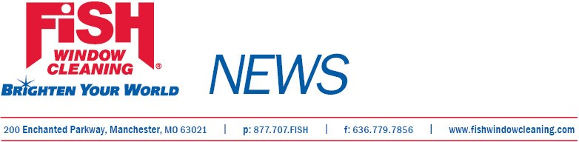
For Immediate Release

Local Business Expands
Adds Territory and Staff

St. Louis, Mo., January 24, 2012--Roland and Barbara Young, owners of Fish Window Cleaning®, Eagleville, Pa., have expanded their territory to include 14 additional zip codes in the Philadelphia area. As part of the expansion the business has hired three more workers and plans to hire additional staff.
The Youngs, who were honored in 2011 with the FISH Rising Star Excellence Award for the Northeast Region, opened their business in February 2004. During the past eight years they have provided commercial and residential cleaning services to 500 accounts in the Philadelphia area.
Fish Window Cleaning was founded in 1978 by S. Michael Merrick and began franchising in 1998. Currently the system has 239 U.S. locations. FISH is the largest window cleaning company in the country. The organization ranked 68th on Dun & Bradstreet’s AllBusiness Allstars 2012 Top 100 Franchises, 119th on Entrepreneur Magazine’s 2012 Franchise 500, 30th among the Top 50 Large Systems in Franchise Business Review’s 2011 Franchisee Satisfaction Awards, and was named to the 2011 Inc. 5000 list of fastest growing businesses.

# # #

Contact: GeGe Mix, gege@fishwindowcleaning.com; 314-707-0896

