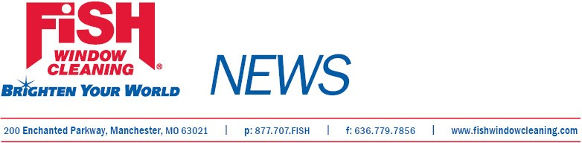

For Immediate Release

Local Business
Receives Award

St. Louis, Mo., August 20, 2012.—Tom Gaslin, owner of Fish Window Cleaning®, Orange Park, received the Navigator Award at the annual Fish Window Cleaning Convention, July 28 in St. Louis.
Gaslin, who was described by fellow franchisees as someone who is “always generous with his time,” was presented with the award in recognition of his work with prospective franchisees. During the convention Gaslin also facilitated a general session featuring franchisees’ “Top 20 Best Practices.”
Fish Window Cleaning® provides services for commercial and residential customers in Jacksonville, Orange Park, Duval County, St. John's County, Clay County, Ponte Vedra, Fleming Island, Green Cove Springs, Middleburg,
St. Augustine, Palm Coast, Flagler Beach, Palatka, Putnam County and Flagler County
Fish Window Cleaning was founded in 1978 and began franchising in 1998. FISH is the largest window cleaning company in the country with over 230 national locations. The organization ranked 14th in the 2012 Franchisee Satisfaction Survey conducted by Franchise Business Review, 68th on Dun & Bradstreet’s AllBusiness Allstars 2012 Top 100 Franchises, 119th on Entrepreneur Magazine’s 2012 Franchise 500, and was named to the 2012 Inc. 5000 list of fastest growing businesses.
.
# # #
Contact: GeGe Mix, gege@fishwindowcleaning.com, 314-707-0896

