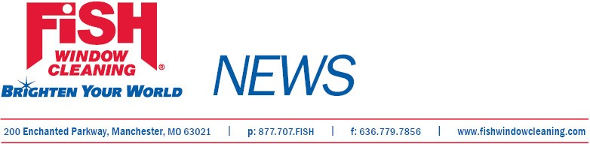

For Immediate Release

Fish Window Cleaning®
Opens New Atlanta Office

St. Louis, Mo., October 10, 2011— Michael Sugg has opened Fish Window Cleaning®, 3625 Brookview Dr., Suite C, Loganville, Ga., www.fishwindowcleaning/3018 .

The business provides window cleaning services to both commercial and residential customers in east Atlanta including Lawrenceville, Snellville, Conyers, Loganville, Lilburn, Lithonia, and Grayson, GA.
Sugg previously was vice president of infrastructure operations for EarthLink. He is a graduate of Georgia Institute of Technology, where he received a degree in computer engineering.
In preparation for opening his business, Sugg completed four weeks of pre-training work and an eight-day training program at Fish Window Cleaning headquarters in St. Louis, Mo.
Fish Window Cleaning has 239 locations in the United States and is the largest window cleaning company in the country. The organization ranked 139th on Entrepreneur Magazine’s 2011 Franchise 500, 61st on the 2011 AllBusiness AllStars Franchise 300, 30th among the Top 50 Large Systems in Franchise Business Review’s 2011 Franchisee Satisfaction Awards, and was named to the 2011 Inc. 5000 list of fastest growing businesses.

Contact: GeGe Mix, gege@fishwindowcleaning.com; 314-707-0896

